**Jenkins**

**Class #1**

* It’s a continuous Integration tool , it’s a Open Source
* .exe,.ear,.jar…etc we can call those as Artifacts
* Jenkins is used for Continuous Integration, Continuous Deployment and Continuous Delivery
* Developers will commit the source code in to Repository(Git), all the committed code will combine in to one Artifact package
* By using that Artifact package and we will make into build(Deployment plan)
* We will deploy that Build

Jenkins, Bamboo, Circe CI all these are CI tools

Jenkins is the Java based Application , its is developed by Java Framework

Its open source Tool.

**Build Tools**

* **Ant**
* **Maven these two tools for java App’**
* **Gradle**
* **MsBuild these two for .Net App**
* Jenkins is a Java base web Application server
* Jenkins will act as CI , once developer will commit code to VCS
* (Git) then Jenkins will come in to picture
* It will fetch the latest code and build it, Deploy it and Test it
* And then notify to developer the output

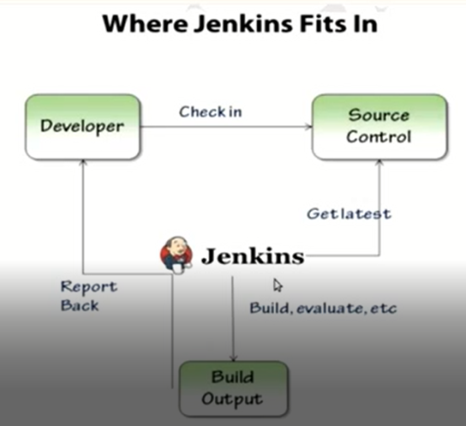

* Jenkins will send the notifications as well once deployment is completed
* We can configure notifications for successful and failure as well
* Jenkins have N-number of plugin’s by using those we can Integrate multiple tools

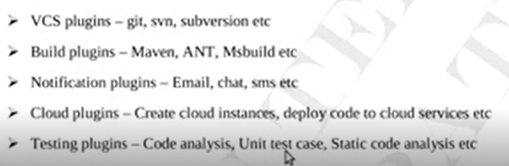

**Unit Testing**

Developers will perform the unit testing , its nothing but checking the functionality of code

Whether it is working as per the requirement or not

By using Jenkins we can perform Unit testing also, unit test cases will implement.

**We can Install Jenkins in Windows and Linux boxes , we need JDK in our machine to Install/Run Jenkins**

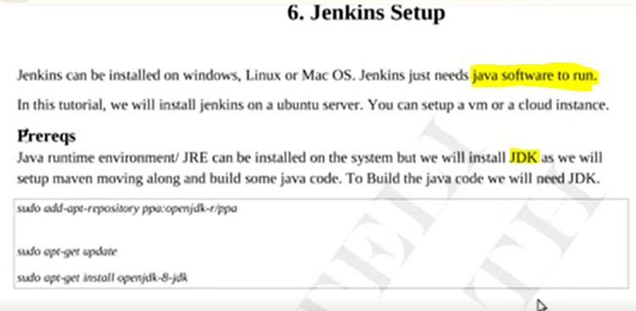

Process to Install Jenkins package

* Before Installing we should update the Repository
* Update the Machine
* And then Install the Jenkins Package

Once we Install Jenkins in Linux machine Jenkins Service will start automatically

To check the status > sudo service Jenkins status

Jenkins will listen the port 8080 by default

Once we install Jenkins in our machine we will access it

When the first time we launch it we need to do some configuration

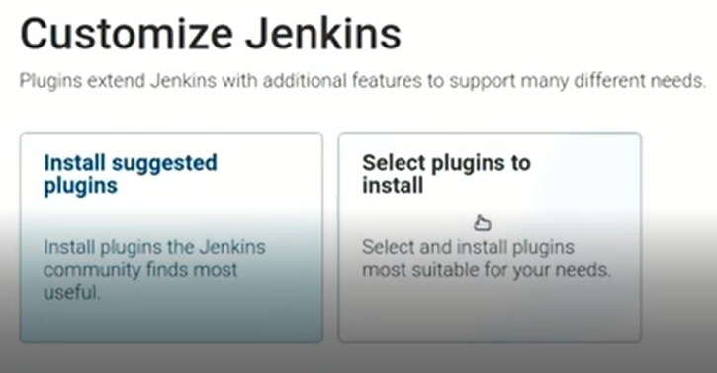

We have to select Install Suggested plugins

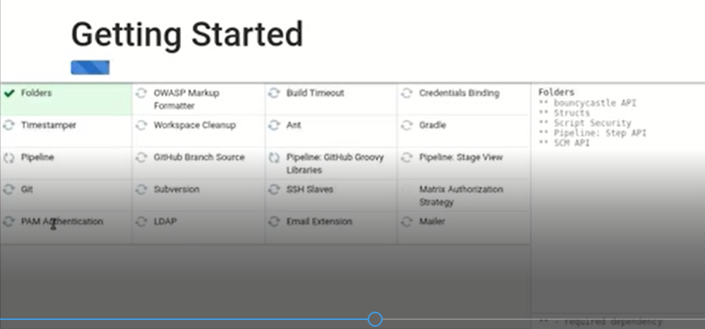

By default above all plugins will install automatically

1st time we have to create our own Admin password for Jenkins login

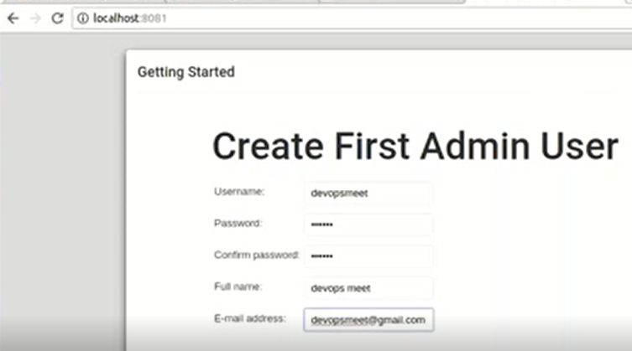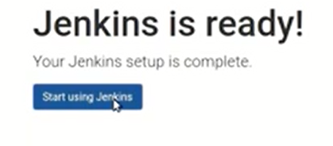

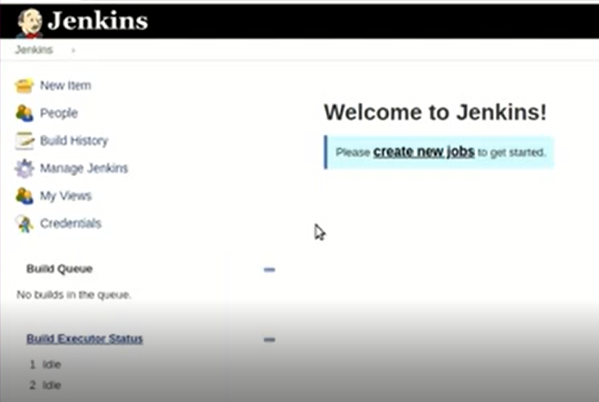

Jenkins Job’s

